Vectors Teaching Set 1
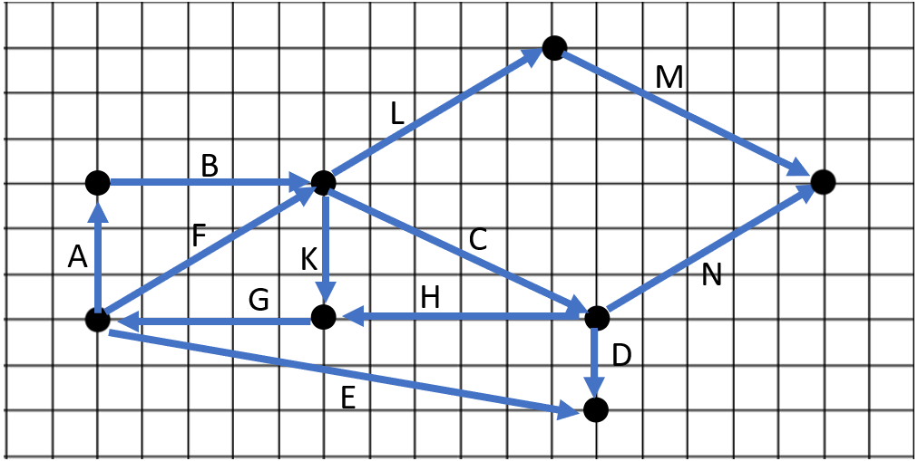
1). [C] Remember that vectors can represent displacements. It will be very useful to feel comfortable thinking about them graphically (instead of numerically), and that’s the purpose of this problem.
Each letter labels a vector. Answer each question by thinking: Are the displacements the same?
a). Is C = M? why? b). Is A + B = F ? why? c). Is A + B = L ? why?
d). Re-write the equation $A+B=L$ with each vector’s components. For example, $A=<0, 3>$, so to start we’ll have $<0, 3>+<___ , ___>$ = $<___, ___>$. Fill in the rest of the blanks and confirm your answer to #3 numerically.
e). C + D = < ___ , ___ > write the 2 numerical components for the resulting vector
f). F – L = < ____, _____> g). Does $C=K+G+E-D$? h). Does C = D – E + F ?
i). Does G + H + E = D? j). Does G + H = E + D? k). What 4 vectors sum to <0, 0>
l). Name 2 vectors that make this true: K + G + F = A + ____ + ____
m). Is $\left\|A\right\|=\left\|K\right\|$ ? why? n). Which is larger: $\left\|C\right\|$ or $\left\|N\right\|$

2. [C/P] Finding an unknown vector numerically and graphically.
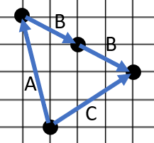
In the last problem you saw that you can visualize an equation graphically.
Let $\vec{A}=<-1, 4>$, and $\vec{C}=<3, 2>$.
If I said “solve for $\vec{B}$” in the equation $\vec{A}+2\vec{B}=\vec{C}$, you could do it numerically, or you could think about it graphically like the picture to the right. You know B has to be half the displacement from the end of A to the end of C.
a). Let $\vec{u}=<-4, 2> and \vec{v}=<1, 5>$. If $3\vec{u}+\vec{b}=\vec{v}$ what’s $\vec{b}$ ?
Sketch the equation graphically. Solve for $\vec{b}$ either graphically or numerically. (But write your solution with numeric components. So, $\vec{b}=<___, ___>$).
b). Let $\overset{⃑}{a}=<2, 3>$. If $3\overset{⃑}{a}+\overset{⃑}{b}+2\overset{⃑}{c}=<2,-1>$ find at least 3 different solutions for what $\overset{⃑}{b}$ and $\overset{⃑}{c}$ could be.
Show your solutions numerically and graphically.
3). [C]
In lecture, we said that when you add two vectors in rectangular form you can add their x components and y components separately.
In other words: $<3, -1> + <-5, 2> = <-2, 1>$
Let’s explore whether the same idea works when you add vectors in polar form.
Is it ALWAYS true, NEVER true or SOMETIMES true that:
$d_{1}∠a_{1}+d_{2}∠a_{2}=\left(d_{1}+d_{2}\right)∠\left(a_{1}+a_{2}\right)$.
Explain using numbers, diagrams, or both.

Vectors Teaching Set 1 – Solutions

1). [C] Each letter labels a vector. Answer each question by thinking: Are the displacements the same?
a). Is C = M?
Yes. As a displacement the vector C means “wherever you start, you’ll end up right 6 and down 3 from the starting place”. The vector M also ends right 6 and down 3 from its starting place; it just starts in a different place. But since vectors only represent the displacement, these are the same displacement.
b). Is A + B = F ? Yes. Remember that A + B can be thought of as “the overall displacement if first you’re displaced by A, and then by B”. So the overall displacement of A followed by B takes you up 3 and right 5. That’s exactly what F does.
If you’re thinking “that’s not graphical; you ended up thinking about it numerically in the end anyway”, that’s only because I have to use language in a book. If we were in person I’d point to the arrows in the diagram and show you the movements. Look and notice that If you start your finger at the start of A, move it along A and then along B, you start and end in the same place as if you started your finger at A and moved it along F. No numbers involved. That’s what I want you to start practicing because it will be very very useful later.
c). Is A + B = L ? why? Yes again. F = L because they’re the same displacement (“wherever you start, you end right 5 and up 3 from the starting point”). So since A + B = F, A + B also equal L.
d). Re-write the equation $A+B=L$ with each vector’s components. For example, $A=<0, 3>$, so to start we’ll have $<0, 3>+<5 ,0>$ = $<5, 3>$. You can see this is true numerically by adding the x components and y components separately.
e). C + D = < 6 ,5 >. You can imagine C + D as a single displacement that starts at the start of C and ends at the end of D. How far over and down do you go when you put them together? Over 6 and down 5.
f). F – L = < 0, 0>. Earlier we decided that F is the same displacement as L. Remember that $F-L$ is the same as $F+(-L)$ where $-L$ is the opposite displacement. It’s as if you did the L displacement backwards by flipping the arrow around from the end to the start. So graphically $F-L$ is like saying “start at the start of F, and go to the end, then do that same displacement backward” – Meaning that you end where you started.

g). Does $C=K+G+E-D$? Yes. You could verif this numerically, but it’s much faster to confirm graphically. Start your finger at the start of C. Follow the K displacement. Then the G displacement. Then the E displacement. Notice that if you follow the D arrow backwards you get to the end of C. That’s exactly what the equation says: $K+G+E-D$ represents following the K, G, and E arrows forward, and the D arrow in reverse. We notice that overall dispalcement starts where C starts and ends where C ends. Therefore it’s the same overall displacement as C.
h). Does C = D – E + F ?
This time the answer is No. Following D, E backwards, then F definitely connects up with the C vector. The problem is we started at the end of C and ended at the start of C. So we ended up 6 to the LEFT and 3 UP from where we started. But the C vector represents the displacement of ending 6 to the RIGHT and 3 DOWN from where we start. In other words: $D-E+F=-C$. We’ve found the opposite of C.
i). Does G + H + E = D? Yes. Remember that $G+H$ is the same as $H+G$ for vectors. So this equation is the same as $H+G+E=D$. Now you can literally start at the start of D, follow the arrows for $H+G+E$ and end at the end of D, confirming the equation.
j). Does G + H = E + D? Nope. An easy way to see this is that $G+H$ involves only horizontal displacement, but doesn’t take us up or down at all. $E+D$ has a vertical displacement of ending down by 4. So they can’t be the same.
k). What 4 vectors sum to <0, 0>. There are lots of possible answers here. We’re just looking for a closed loop. One answer might be: $F+C+H+G=<0, 0>$. Since F and L are the same vector, you could also write $L+C+H+G=<0, 0>$. Another answer is $A+B+K+G=<0, 0>$. If we allow negative vectors, you could do something like $L+M-N-C=<0, 0>$. In part i we found that $G+H+E=D$. If we subtract D from both sides we get $G+H+E-D=<0, 0>$ which is another answer.
l). Name 2 vectors that make this true: K + G + F = A + ____ + ____
Since $K+G+F=<0, 0>$ we’re looking for two vectors that combine with A that also make a net displacement of $<0, 0>$. Looking at the picture, $A+B-F$ is the most immediate one that works.
m). Is $\left\|A\right\|=\left\|K\right\|$ ? Remember that $\left|\left|A\right|\right|$ represents the magnitude (or, length) of the A vector. Here A and K both have a length of 3, so yes.
m). Which is larger: $\left\|C\right\|$ or $\left\|N\right\|$. Here C and N have the same vertical displacement (but in opposite directions) – they both displace vertically by 3. Imagine using the pythagorean theorem to find the length of C and N as the two hypotenuses of right triangles. C horizontally displaces by 6 and N horizontally displaces by 5. Therefore C must have the longer hypotenuse.

2. [C/P] Finding an unknown vector numerically and graphically.

In the last problem you saw that you can visualize an equation graphically.
Let $\vec{A}=<-1, 4>$, and $\vec{C}=<3, 2>$.
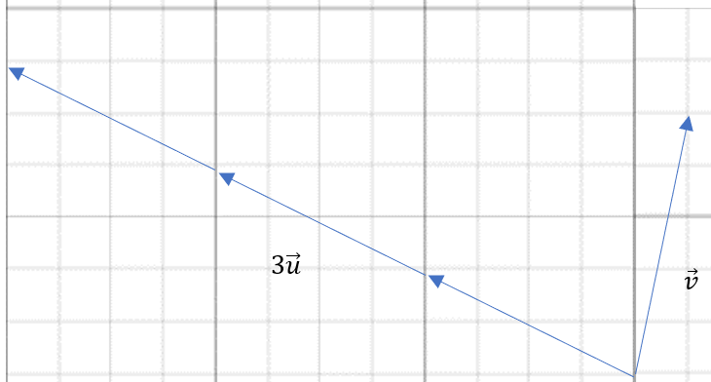
If I said “solve for $\vec{B}$” in the equation $\vec{A}+2\vec{B}=\vec{C}$, you could do it numerically, or you could think about it graphically like the picture to the right. You know B has to be half the displacement from the end of A to the end of C.
a). Let $\vec{u}=<-4, 2> and \vec{v}=<1, 5>$.
If $3\vec{u}+\vec{b}=\vec{v}$ what’s $\vec{b}$ ?
Here we can ask: “If I do 3 of the $\vec{u}$ displacements, what displacement can I do afterwards that’s the same overall as the $\vec{v}$ displacement?”
Looking at the picture, seems pretty clear that going right by 13 and down by 1 will work.
Numerically you can also solve: $3\vec{u}+\vec{b}=\vec{v}$. Subtract $3\vec{u}$ to isolate $\vec{b}$ giving:
$$\vec{b}=\vec{v}-5\vec{u} = <1, 5>-3⋅<-4, 2>$$
$$\vec{b}=<1, 5>-<-12, 6>$$
$$\vec{b}=<1, 5>+<12,-6>$$
$$\vec{b}=<13,-1>$$
b). Let $\overset{⃑}{a}=<2, 3>$. If $3\overset{⃑}{a}+\overset{⃑}{b}+2\overset{⃑}{c}=<2,-1>$ find at least 3 different solutions for what $\overset{⃑}{b}$ and $\overset{⃑}{c}$ could be.
Here there are two unknown vector. Let’s compare the situation to solving a regular algebraic equation with two unknowns. Say you know $x=3$ and you wanted to solve $3x+y+2z=10$.
You’d have $9+y+2z=10$ or $y+2z=1$. There are lots of pairs of numbers that make this true. Say $y=9$. Then $9+2z=1$ means $z=-4$. If $y=-3$ then $-3+2z=1$ means that $z=2$. The key is to realize that no matter what you choose for one variable, you can solve for what the other must be to keep the equation true.
We’re in that same situation with vectors. We have: $3⋅<2, 3>+\overset{⃑}{b}+2\overset{⃑}{c}=<2,-1>$. You can think of it this way: $<6, 9>+<?, ?>+2⋅<?, ?> = <2, -1>$. Looking at just the horizontal parts you could write: $6 + ? + 2⋅? =2$ and then fill in values for the two ?’s that make the equation true. Do the same for y, and you’ve got some vectors that work.
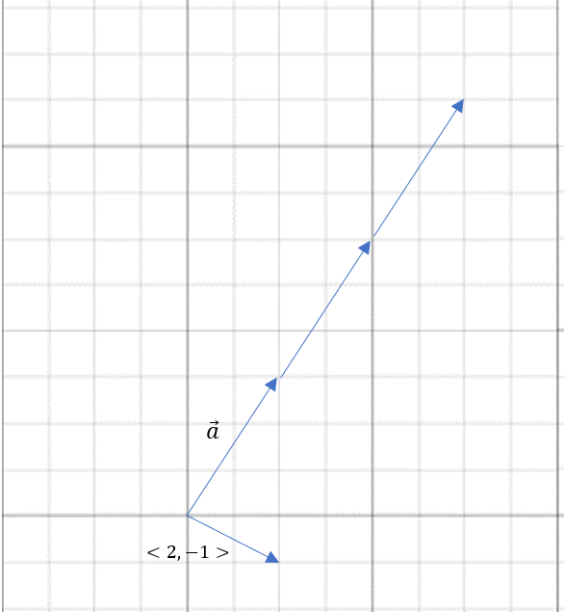
A much easier way to think about it, in my opinion, is graphically. Let’s look at at what we’ve got.
How can you interpret $3\overset{⃑}{a}+\overset{⃑}{b}+2\overset{⃑}{c}=<2,-1>$ graphically? We want to follow the 3 $\vec{a}$ vectors, then add an arrow $\vec{b}$ followed by 2 $\vec{c}$ arrows, end-to-end, and have them end up at the end of $<2, -1>$.
I can literally pick any $\vec{b}$ arrow I want, and then take the remaining part and divide it in half to find the $\vec{c}$. The diagram to the right shows two very different options.
In one: $\vec{b}=<2, -4>$ and $\vec{c}=<-3,-3>$
Plugging everything into the original equation gives: $3⋅<2, 3>+<2, 4>+2⋅<-3, -3> =<2,-1>$. You can work out numerically that these are equal.
My other solution has: $\vec{b}=<-10,-10>$ and $\vec{c}=<3, 0>$. Again, you can plug them in and verify numerically they work.

3). [C] In lecture, we said that when you add two vectors in rectangular form you can add their x components and y components separately.
In other words: $<3, -1> + <-5, 2> = <-2, 1>$
Let’s explore whether the same idea works when you add vectors in polar form.
Is it ALWAYS true, NEVER true or SOMETIMES true that:
$d_{1}∠a_{1}+d_{2}∠a_{2}=\left(d_{1}+d_{2}\right)∠\left(a_{1}+a_{2}\right)$.
Let’s tinker around with a simple example. Say I make both vectors $2 ∠ 45°$. The question is, if I follow that displacement twice, is it the same as the displacement I’d get if I added the distances and angles separately. In other words, I want to know if: $2 ∠ 45°+2 ∠ 45°=4 ∠ 90°$
If you look at the $2∠45°$ vector and add two of them end to end, it’s clearly $4 ∠ 45°$. So it looks like the distances added but the angles didn’t. What made them add? It’s because the angles were pointed in the same direction.
If the angles aren’t pointing in the same direction, as in $3 ∠ 0°+4 ∠ 90°$, neither distances nor angles add to give you the result.
So it looks like the answer is SOMETIMES. Only when the angle of both vectors is 0. In this case the resulting angle is also 0 – not because they actually added, but because the resulting angle of 0 is the same as what you’d get if you added 0 + 0.

